**Pseudocode**

Begin

Set the base investment amount to $1000

Set the expected yearly growth rate to 7%

Repeat for each year from 1 to 30:

Compute the projected amount using:

new_value = base * (1 + growth_rate) ^ year

Display the year and its corresponding value

End

**Source Code**

# SmartSaver: Investment Return Estimator

# Author: Ian Patricio

# Description: Simulates how an initial investment grows annually over 30 years.

# Starting funds and annual return rate

starting_funds = 1000.0 # dollars

growth_rate = 0.07 # 7% annual increase

# Header

print("📈 SmartSaver - 30-Year Investment Outlook 📈")

print("--------------------------------------------")

print(f"{'Year':<6}{'Projected Value ($)':>20}")

print("--------------------------------------------")

# Simulate year-by-year growth

for period in range(1, 31):

value = starting_funds * ((1 + growth_rate) ** period)

print(f"{period:<6}{value:>20,.2f}")

Screenshots:

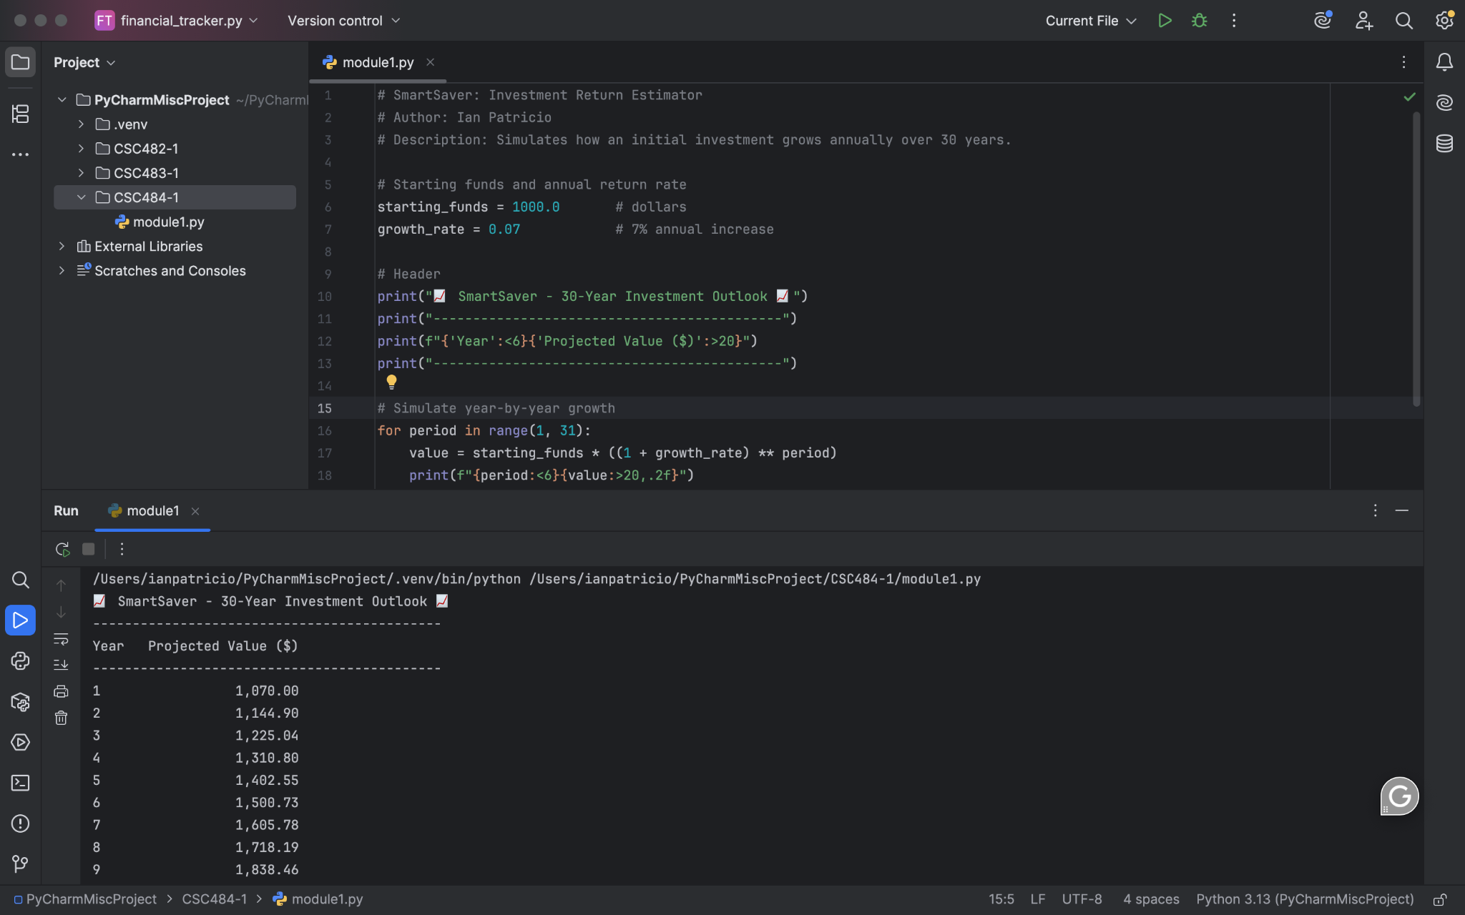

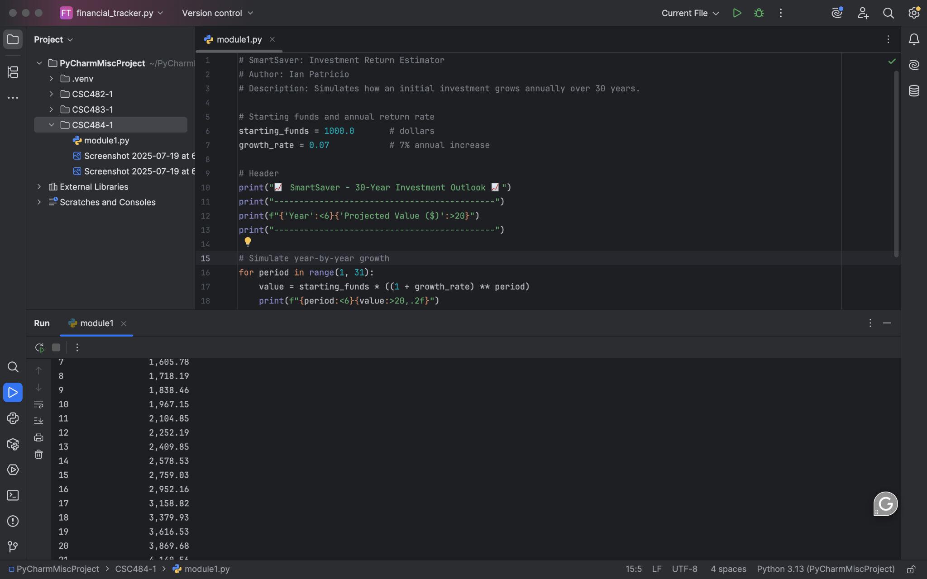

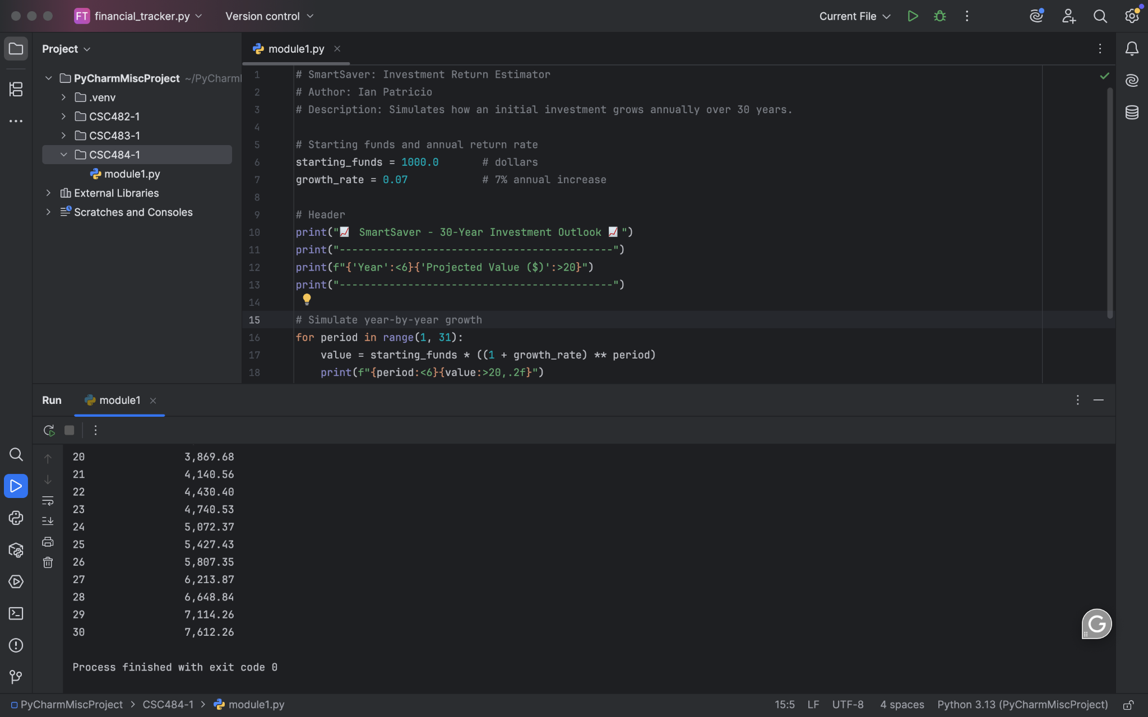

My Git Repository: https://github.com/ianpatricio-csuglobal/CSC484-1